**Practical No: 19**

**Aim :** Implementation of database connection in PHP

**Performed By :** Piyush Vanjari

**Class :** BCA-III SEM-VI

**Date :** 13/02/2025

**Code :**

**db_connection.php**

<?php

function OpenCon() {

$dbhost = "localhost";

$dbuser = "root";

$dbpass = ""; // Default is empty for XAMPP

$dbname = "practice";

$conn = new mysqli($dbhost, $dbuser, $dbpass, $dbname);

if ($conn->connect_error) {

die("Connection failed: " . $conn->connect_error);

}

return $conn;

}

function CloseCon($conn) {

$conn->close();

}

?>

**index.php**

<?php

include 'db_connection.php';

$conn = OpenCon();

if ($conn instanceof mysqli) {

echo "Connected Successfully using MySQLi";

} else {

echo "Unexpected connection type.";

}

CloseCon($conn);

?>



**index.php**

<!DOCTYPE html>

<html lang="en">

<head>

<title>GFG- Store Data</title>

</head>

<body>

<center>

<h1>Storing Form data in Database</h1>

<form action="insert.php" method="post">

<p>

<label for="firstName">First Name:</label>

<input type="text" name="first_name" id="firstName">

</p>

<p>

<label for="lastName">Last Name:</label>

<input type="text" name="last_name" id="lastName">

</p>

<p>

<label for="Gender">Gender:</label>

<input type="text" name="gender" id="Gender">

</p>

<p>

<label for="Address">Address:</label>

<input type="text" name="address" id="Address">

</p>

<p>

<label for="emailAddress">Email Address:</label>

<input type="text" name="email" id="emailAddress">

</p>

<input type="submit" value="Submit">

</form>

</center>

</body>

</html>

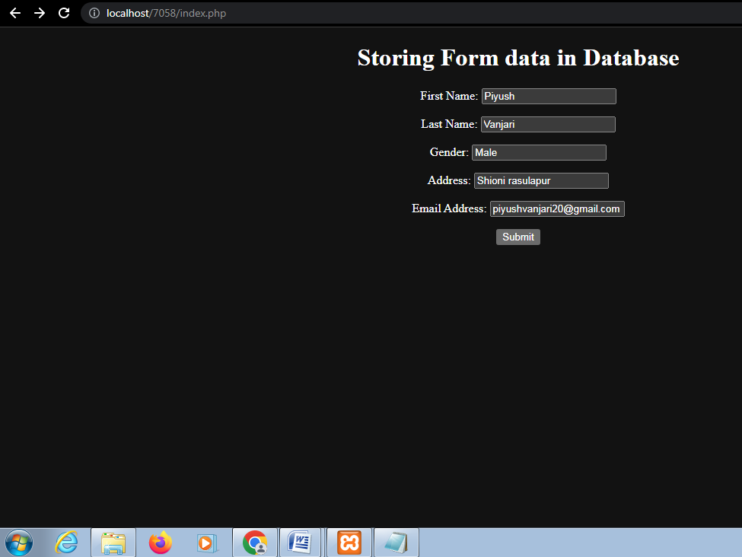

**insert.php**

<html>

<head>

<title>Insert Page page</title>

</head>

<body>

<center>

<?php

$conn = mysqli_connect("localhost", "root", "", "staff");

if($conn === false){

die("ERROR: Could not connect. "

. mysqli_connect_error());

}

$first_name = $_REQUEST['first_name'];

$last_name = $_REQUEST['last_name'];

$gender = $_REQUEST['gender'];

$address = $_REQUEST['address'];

$email = $_REQUEST['email'];

$sql = "INSERT INTO college VALUES ('$first_name',

'$last_name','$gender','$address','$email')";

if(mysqli_query($conn, $sql)){

echo "<h3>data stored in a database successfully."

. " Please browse your localhost php my admin"

. " to view the updated data</h3>";

echo nl2br("\n$first_name\n $last_name\n "

. "$gender\n $address\n $email");

} else{

echo "ERROR: Hush! Sorry $sql. "

. mysqli_error($conn);

}

mysqli_close($conn);

?>

</center>

</body>

</html>

